Hyperarea

Definition
# Source: AI Source: Provided by: [Data Path: Persons Table -> ID Column: 1, Name_En Column: Motasem Essam] -> From: [ChatGPT] on [7/20/2026]
Hyperarea is the measure of the boundary or surface of a geometric object in higher-dimensional space. It is the higher-dimensional extension of the familiar concept of area.
For an n-dimensional object, its hyperarea measures the size of its (n−1)-dimensional boundary.
Examples:
- A 2D square has a 1D boundary (its perimeter).
- A 3D cube has a 2D boundary (its surface area).
- A 4D hypercube (tesseract) has a 3D boundary, whose measure is called its hyperarea.

Characteristics
# Source: AI Source: Provided by: [Data Path: Persons Table -> ID Column: 1, Name_En Column: Motasem Essam] -> From: [ChatGPT] on [7/20/2026]
Hyperarea:
- Measures the boundary of higher-dimensional objects.
- Is one dimension lower than the object itself.
- Generalizes the concept of surface area.
- Is expressed in units raised to one less than the object's dimension.
- Is mainly used in higher-dimensional geometry and advanced mathematics.

Dimensional Progression
# Source: AI Source: Provided by: [Data Path: Persons Table -> ID Column: 1, Name_En Column: Motasem Essam] -> From: [ChatGPT] on [7/20/2026]
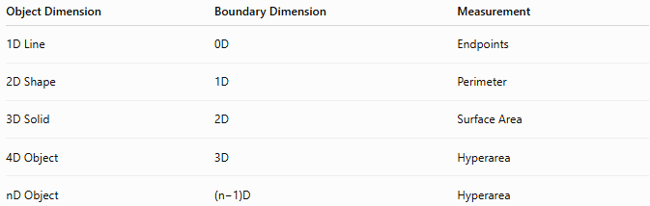
Object Dimension | Boundary Dimension | Measurement
1D Line | 0D | Endpoints
2D Shape | 1D | Perimeter
3D Solid | 2D | Surface Area
4D Object | 3D | Hyperarea
nD Object | (n−1)D | Hyperarea

Illustration
# Source: AI Source: Provided by: [Data Path: Persons Table -> ID Column: 1, Name_En Column: Motasem Essam] -> From: [ChatGPT] on [7/20/2026]
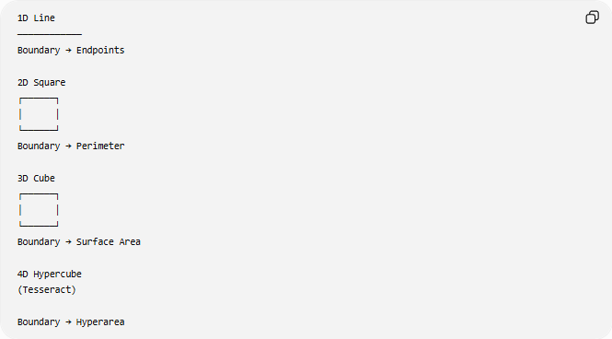
1D Line
────────────
Boundary → Endpoints

2D Square
┌──────┐
│ │
└──────┘
Boundary → Perimeter

3D Cube
┌──────┐
│ │
└──────┘
Boundary → Surface Area

4D Hypercube
(Tesseract)

Boundary → Hyperarea

Mathematical Representation
# Source: AI Source: Provided by: [Data Path: Persons Table -> ID Column: 1, Name_En Column: Motasem Essam] -> From: [ChatGPT] on [7/20/2026]
Hyperarea is commonly represented by:
$$A_{n}$$
where:
- $A_{n}$= Hyperarea of an $n$-dimensional object

Hypercube Hyperarea
# Source: AI Source: Provided by: [Data Path: Persons Table -> ID Column: 1, Name_En Column: Motasem Essam] -> From: [ChatGPT] on [7/20/2026]
For an $n$-dimensional hypercube with side length $s$:
$$A_{n}=2n s^{ n-1}$$

Examples
# Source: AI Source: Provided by: [Data Path: Persons Table -> ID Column: 1, Name_En Column: Motasem Essam] -> From: [ChatGPT] on [7/20/2026]
Square (2D)
$$P=4s$$
The boundary is one-dimensional (perimeter).

Cube (3D)
$$SA=6s^{2}$$
The boundary is two-dimensional (surface area).

Tesseract (4D)
$$A_{4}=8s^{3}$$
Its boundary consists of 8 cubic cells, so its hyperarea is measured in cubic units.

Units
# Source: AI Source: Provided by: [Data Path: Persons Table -> ID Column: 1, Name_En Column: Motasem Essam] -> From: [ChatGPT] on [7/20/2026]
Hyperarea is measured in units raised to one less than the object's dimension.
Examples:
- m³ (boundary of a 4D object)
- cm³
- ft³
- m⁴ (boundary of a 5D object)

Applications
# Source: AI Source: Provided by: [Data Path: Persons Table -> ID Column: 1, Name_En Column: Motasem Essam] -> From: [ChatGPT] on [7/20/2026]
Hyperarea is used in:
- Higher-Dimensional Geometry
- Topology
- Differential Geometry
- Linear Algebra
- Multivariable Calculus
- Theoretical Physics
- String Theory
- Computational Geometry
- Data Science
- Machine Learning

Advantages
# Source: AI Source: Provided by: [Data Path: Persons Table -> ID Column: 1, Name_En Column: Motasem Essam] -> From: [ChatGPT] on [7/20/2026]
Studying hyperarea helps to:
- Generalize boundary measurements.
- Analyze higher-dimensional objects.
- Support mathematical modeling.
- Study multidimensional spaces.
- Develop advanced geometric theories.

Limitations
# Source: AI Source: Provided by: [Data Path: Persons Table -> ID Column: 1, Name_En Column: Motasem Essam] -> From: [ChatGPT] on [7/20/2026]
Hyperarea:
- Cannot be directly visualized beyond three dimensions.
- Requires advanced mathematics.
- Has limited direct physical interpretation in everyday life.

Comparison with Other Measurements
# Source: AI Source: Provided by: [Data Path: Persons Table -> ID Column: 1, Name_En Column: Motasem Essam] -> From: [ChatGPT] on [7/20/2026]
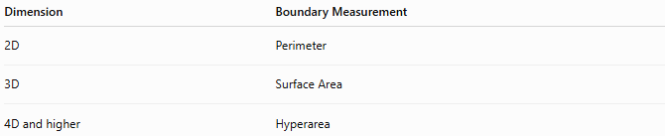
Dimension | Boundary Measurement
2D | Perimeter
3D | Surface Area
4D and higher | Hyperarea

Key Points
# Source: AI Source: Provided by: [Data Path: Persons Table -> ID Column: 1, Name_En Column: Motasem Essam] -> From: [ChatGPT] on [7/20/2026]
- Hyperarea measures the boundary of a higher-dimensional object.
- It is the higher-dimensional extension of surface area.
- For an $n$-dimensional hypercube:
$$A_{n}=2n s^{ n-1}$$
- Hyperarea is measured in units corresponding to the boundary's dimension (e.g., m³ for a 4D object's boundary).
- It is widely used in higher-dimensional geometry, topology, theoretical physics, computational geometry, and advanced mathematics.

Conclusion
# Source: AI Source: Provided by: [Data Path: Persons Table -> ID Column: 1, Name_En Column: Motasem Essam] -> From: [ChatGPT] on [7/20/2026]
Hyperarea is the higher-dimensional extension of surface area and measures the boundary of objects in four or more dimensions. While a cube has a two-dimensional surface area, a four-dimensional hypercube has a three-dimensional boundary whose measure is its hyperarea. Although hyperarea cannot be directly visualized beyond three dimensions, it is fundamental in higher-dimensional geometry, topology, multivariable calculus, theoretical physics, computational geometry, machine learning, and advanced mathematical modeling, where the properties of multidimensional spaces are studied.

